Lecture 03: Flowchart

Definition
Flowchart is a diagrammatic representation of a sequence of logical steps of a program. Flowcharts use simple geometric shapes to depict processes and arrows to show relationships and process/data flow.

Benefits of Flowcharts
1. Simplify the Logic:
- By providing a pictorial representation of the steps, flowcharts simplify the logic and subsequent processes.
2. Makes Communication Better:
- With easily understandable pictorial logic and steps, flowcharts serve as a simple and effective way to communicate processes.
3. Effective Analysis:
- Once a flowchart is prepared, analyzing the problem becomes straightforward and efficient.
4. Useful in Coding:
- Flowcharts provide clear directions on what, when, and where actions should be performed, making the coding process more efficient.
5. Proper Testing:
- Flowcharts help identify errors in a program efficiently by following the logical sequence.
6. Applicable Documentation:
- Flowcharts facilitate the preparation of proper documentation, ensuring clarity and understanding once the code is written.

Guidelines to Develop Flowcharts
- A flowchart should have only one start and one stop symbol.
2. Use numbers for on-page connectors and alphabets for off-page connectors.
3. The general flow of processes should be from top to bottom or left to right.
4. Arrows should not cross each other to maintain clarity.
5. Use simple and clear symbols to represent processes.

What are the Basic Symbols of a Flowchart?
Let's go over each flowchart symbol individually.
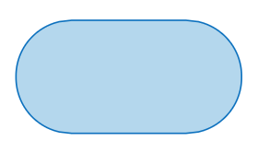

Start/End Symbol
The terminator symbol marks the starting or ending point of the system. It usually contains the word "Start" or "End."


Action or Process Symbol
A box can represent a single step ("add two cups of flour"), or an entire sub-process ("make bread") within a larger process.
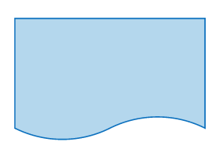

Document Symbol
A printed document or report.
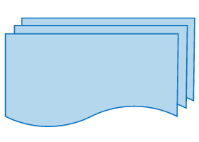

Multiple Documents Symbol
Represents multiple documents in the process
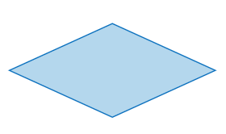

Decision Symbol
A decision or branching point. Lines representing different decisions emerge from different points of the diamond.
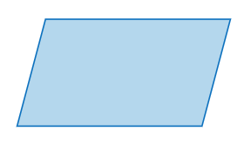

Input/Output Symbol
Represents material or information entering or leaving the system, such as customer order (input) or a product (output).
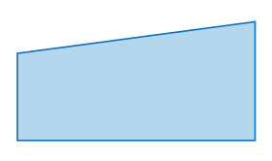

Manual Input Symbol
Represents a step where a user is prompted to enter information manually.
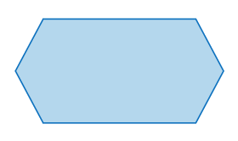

Preparation Symbol
Represents a set-up to another step in the process.
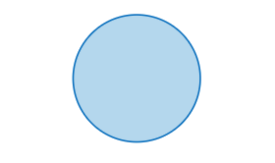

Connector Symbol
Indicates that the flow continues where a matching symbol (containing the same letter) has been placed.
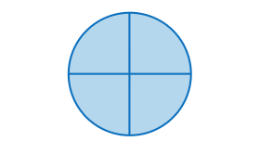

Or Symbol
Indicates that the process flow continues in more than two branches.


Summoning Junction Symbol
Indicates a point in the flowchart where multiple branches converge back into a single process.
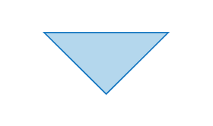

Merge Symbol
Indicates a step where two or more sub-lists or sub-processes become one.


Collate Symbol
Indicates a step that orders information into a standard format.
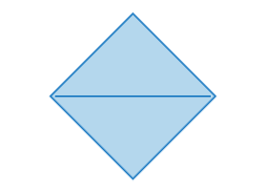

Sort Symbol
Indicates a step that organizes a list of items into a sequence or sets based on some pre-determined criteria.
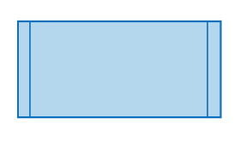

Subroutine Symbol
Indicates a sequence of actions that perform a specific task embedded within a larger process. This sequence of actions could be described in more detail on a separate flowchart.
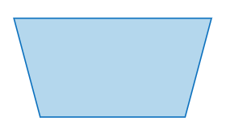

Manual Loop Symbol
Indicates a sequence of commands that will continue to repeat until stopped manually.
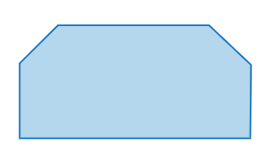

Loop Limit Symbol
Indicates the point at which a loop should stop.
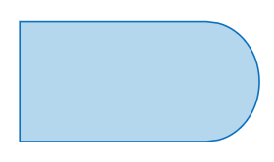

Delay Symbol
Indicates a delay in the process.
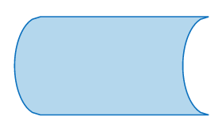

Data Storage or Stored Data Symbol
Indicates a step where data gets stored.
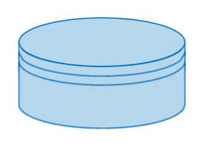

Database Symbol
Indicates a list of information with a standard structure that allows for searching and sorting.
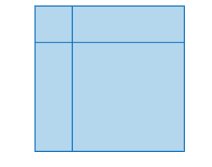

Internal Storage Symbol
Indicates that information was stored in memory during a program, used in software design flowcharts.
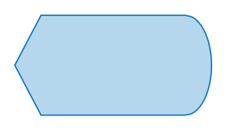

Display Symbol
Indicates a step that displays information.
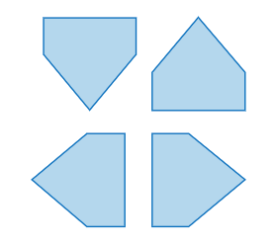

Off Page
Indicates that the process continues off page.

When to Draw Flowchart?
Using a flowchart has a variety of benefits:
- It helps to clarify complex processes.
- It identifies steps that do not add value to the internal or external customer, including delays; needless storage and transportation; unnecessary work, duplication, and added expense; breakdowns in communication.
- It helps team members gain a shared understanding of the process and use this knowledge to collect data, identify problems, focus discussions, and identify resources.
- It serves as a basis for designing new processes.

Example 01
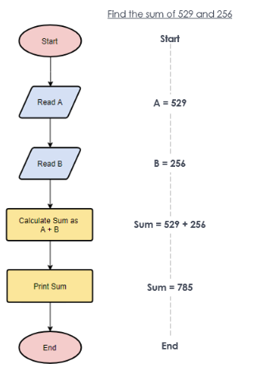
Example 02
Calculate profit or Lost
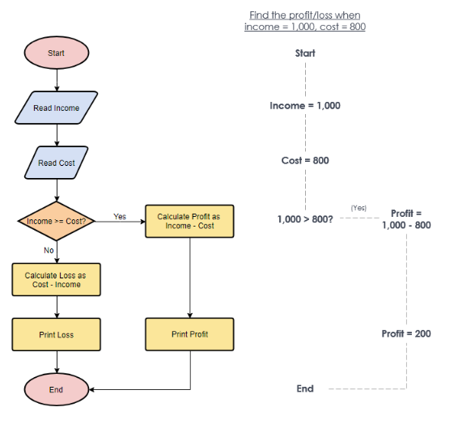

Exercises
1. Basic Exercises:
- Add 10 and 20.
- Find the sum of 5 numbers.

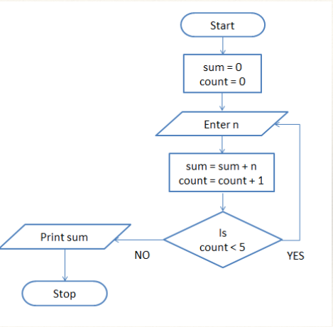

Print 'Hello World' 10 times.

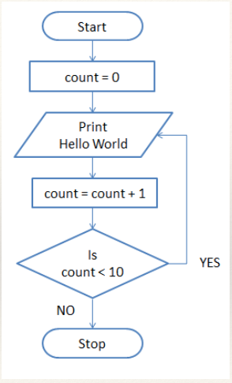

- Draw a flowchart to log in to a Facebook account.

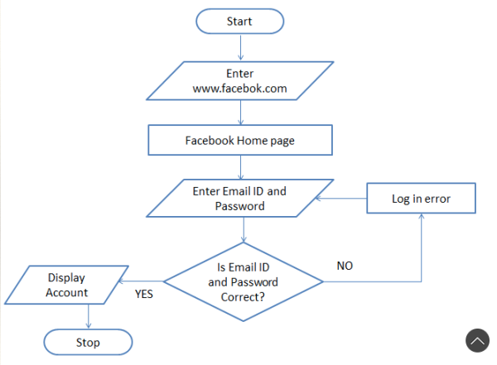

2. Intermediate Exercises:
- Create a flowchart for deciding what to wear based on the weather conditions.

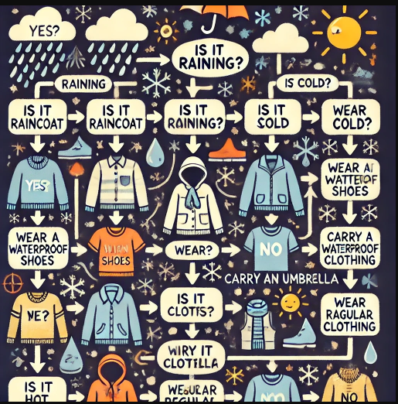

• Is it raining?
- If yes, prepare for wet weather with a raincoat, waterproof shoes, and an umbrella.
- If no, proceed to the next condition.
• Is it cold?
- If yes, dress warmly with a jacket, scarf, gloves, and warm clothing.
- If no, move to the next condition.
• Is it hot?
- If yes, opt for light, breathable clothing made of fabrics like cotton or linen.
- If no, evaluate the general climate.
• Is it windy?
- If yes, wear windproof outerwear or layers to protect yourself from the chill.
• Is it snowy or icy?
- If yes, choose insulated and waterproof clothing, including boots with good grip.
• Is the weather mild or neutral?
- If yes, casual and comfortable clothing appropriate for the season works best.
• Is there a drastic temperature change expected?
- If yes, consider layering so you can adjust your outfit as needed.
- Develop a flowchart for your morning routine, such as preparing breakfast or getting ready for the day.
- Design a flowchart for a simple number guessing game.

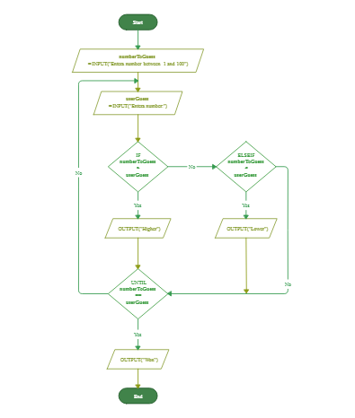
3. Advanced Exercises:
- Design a flowchart for a basic calculator that can perform addition, subtraction, multiplication, and division.
- Create a flowchart for managing a simple shopping list, where items are added or removed based on user input.
- Develop a flowchart for a basic task management system that assigns tasks based on priority.

Detailed Walkthrough
Let's walk through creating a simple flowchart step-by-step:
1. Start with a clear understanding of the problem or process you want to depict.
2. Identify all the major steps and decision points.
3. Use appropriate symbols:
- Ovals for start and stop points.
- Rectangles for processes or actions.
- Diamonds for decision points.
- Arrows to indicate the flow of the process.
4. Arrange the steps logically, ensuring the flow is easy to follow and symbols do not overlap.
Example:
- Problem: Draw a flowchart to make a cup of tea.
- Steps: Start, Boil water, Add tea leaves, Let it brew, Pour into cup, Add sugar/milk as desired, Stop.
- Draw the flowchart using the above guidelines.

QUIZ 01
The ATM machines of ABC Bank use two-factor authentication via an SMS besides conventional PIN control. The customers of ABC bank have a choice either to use a card and a PIN or an SMS authentication. Other banks customers can also withdraw cash from ATMs of ABC bank but only with a Card and a PIN option. After three consecutive unsuccessful attempts, a customer’s card is seized by the machine.

Draw a flowchart only for the cash withdrawal process of ABC’s ATM. (10 marks)

